MLA Format ‘Cheat Sheet’
1. Margins should be set at 1 inch on all sides. (This is the default setting, so it should already be set this way. To check, click the ‘Page Layout’ tab and click ‘Margins’ to see if they are set at 1” on all sides.
2. Your paper should be in 12 point Times New Roman font. Change this on the ‘home tab’ before typing anything.
3. Your paper should be double spaced. You can set your paper to double space before you start typing by clicking on an icon on the “Home” tab in the “Paragraph” box. The icon has lines with and up arrow and a down arrow on the left-hand side. Click this icon and choose ‘2.0’. Also, click on the icon and choose “remove space before/ after paragraphs” so that they paper doesn’t have extra space between lines.
4. Your last name and page number should be on every page. In Microsoft Word, click on the “Insert” tab. Then, click on “Page Number”. Then, put mouse arrow over “top of page”. Scroll down to “Accent Bar Two”. Erase “Page” and type in your last name.
5. The MLA heading (the same one you put on your papers in class) should be in the top left hand corner of your paper: your full name, then “Ms. Maples”, then name of class & period (ex: English 11 Period 4), then date the essay is due written in this format—day/ month/ year (example: 18 September 2012).
6. Your title should be centered above your first paragraph (hit the ‘center’ icon in the paragraph box)
7. Hit the ‘enter’ key and then hit the ‘left justified’ button on the “Home” tab so that all of your paragraphs are not centered like your title. For each new paragraph, hit the ‘enter’ key and the ‘tab’ key so that each paragraph is indented 0.5 inches.
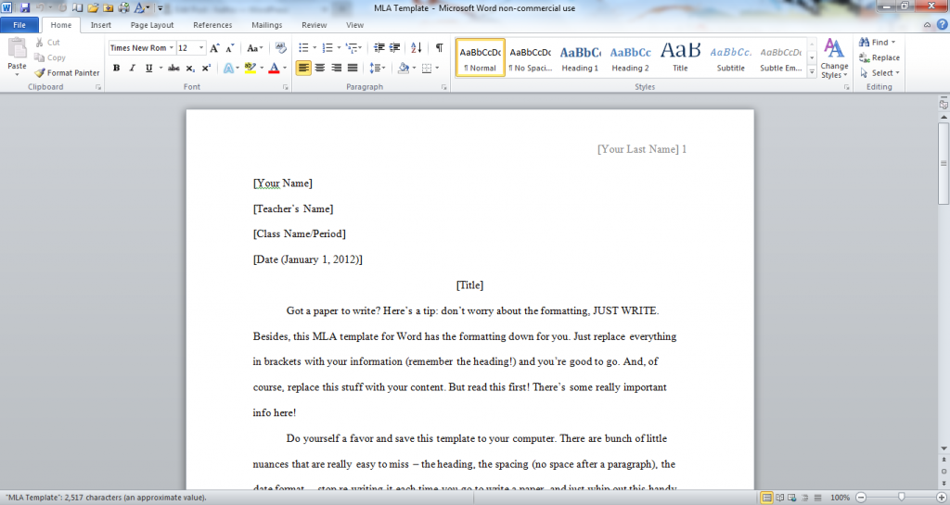

Turnitin.com ‘Cheat Sheet’
1. Log on to computer and go to turnitin.com.
2. Click ‘create account’ at the top of the page.
3. Under ‘create a new account’ click ‘student’. Fill out page.
4. Class Ids below:
Period 1: 8641229
Period 3: 8641216
Period 4: 8641236
ALL CLASSES: class enrollment password is maples all lower case.

5. Make sure you save your essay in the folder with your ID number and/ or on your flash drive (ask Ms. Maples for help if you don’t know where/ how to save essay. She can also show you how to email your essay to yourself so you can work on it at home).
6. To upload your essay, click on the link for your English class. Next, find the assignment and hit ‘submit’.
7. Browse and upload your assignment (choose ‘single file upload’). You will then see the first page of your essay to be sure you picked the right file. If you picked the right file, confirm it and finish submission.
Note: you can only submit once, so don’t submit until you are finished!

***Practice submission: follow Ms. Maples instructions/ your MLA cheat sheet to set up your document in MLA format. Next, write her 2-3 sentences about how your autobiographical narrative is coming along. Save the file on your home drive (the one with your ID number) as “MLA Format.” Upload the document as a ‘single file upload’ under the assignment “Practice Submission.”

